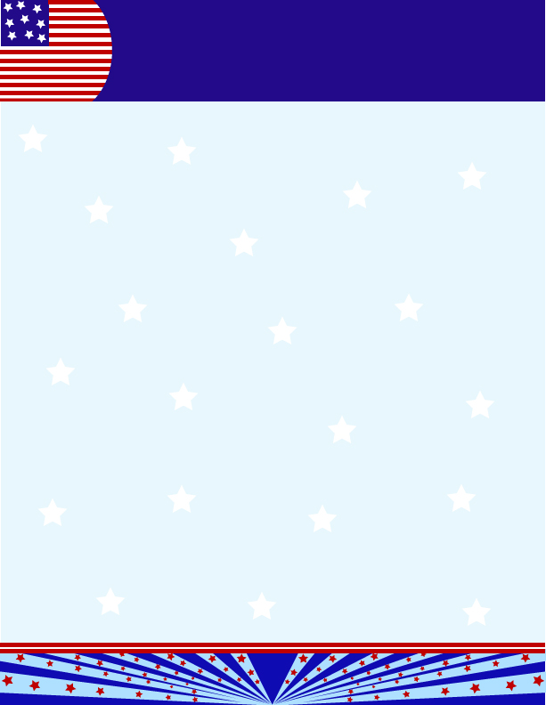
Notes from the Teacher

Wow! Our first round of poems went great! Thank you for all your hard work at home helping your children be successful. New poems will come home in a few weeks.
Our spelling words will quickly become more challenging. Have your child practice reading and writing their words until they are automatic. Sounding the words out is a good skill for unfamiliar words but we want students to be able to recognize their spelling words without saying the individual sounds when they “read for reading”. If your child is struggling with reading, use their full 15 minutes of reading to work on spelling words and their decodable. Faster readers should only spend a few minutes on these and then move on to more difficult material.
Speaking of reading, many of our students have similar interests so when we go to the library the books they want are already checked out. Ask your child what they want to read about and check out the public library or the Scholastic book fair coming next week. The most common requests are Legos, Star Wars, Princesses and Super Heroes.
This Friday is the last day of the grading period. Attendance is very important this week. Tests that are not made up by the end of the grading period can really hurt your child’s grades. Please contact your child’s teacher to see when they can make up their tests if they are absent. Friday is also a half day!!! Send a snack since student will not have lunch that day. Email us with any questions or concerns!

http://legacytraditionalschool-maricopa-1stgrade.yolasite.com/
Login: 1stgradeLTS
Password: legacy1st
DRESS CODE
Some things to remember when
dressing your child

- Plain bottoms khaki, navy, or dark denim. No cargo pants
- Undershirts must be solid red, white or navy
- Shirts must be red, white or navy (sorry no baby blue)
- Shirts tucked in at all times!
- Violation slips will be sent home


Dates to Remember

September 5th-7th Poems Due

September 14th - ½ Day: End of Grading Period 1; Dress Down $1

September 20th -21st - ½ Day: Parent-Teacher Conferences

October 5th - Early Release Day/ Progress Report 2

October 8th – 12th - No School, Fall Break
Teacher Contact Info:

Mrs. Masters
(Mrs. Hendrix’s Class)
Jeanette.Masters@legacytraditional.org
Mrs. Fraser
Rachael.Fraser@legacytraditional.org
Mrs. Ortiz
Cheryl.Ortiz@legacytraditional.org
Mrs. Bennett
Shawna.Bennett@legacytraditional.org
Mrs. Moran
Jennifer.Moran@legacytraditional.org

1st Grade News
1st Grade is Fantastic!
ISSUE 6
September 10, 2012

What are we learning?
Phonograms: Introducing aw, ck, wh, ed, ew, ui, oa, gu, ph Daily Oral and Written Phonogram Review (OPR,WPR) WRITTEN PHONOGRAM TEST FRIDAY!!! Oral Phonogram Test Friday

Spelling- Enter words my-into in the Spelling Notebook. Spelling Test Friday!!!! Reading the Spelling words Assessment Friday!!!

Grammar: Rhyming Words, Oral Sentences, Declarative Sentences, Interrogative Sentences, Subject Nouns. Grammar Test Friday!!

Reading: Informatives, Narrative Elements: Characters, Plot, Setting, Author’s Purpose. Emotional Appeal. Rock and Jazz Comprehension Test Friday!!!

Math: Identifying and sorting common geometric shapes by attributes, drawing pictures and writing number sentences for Some, some more and Some, some went away stories, dividing shapes in half, identifying a fractional part of a whole, Dividing a square in half 2 different ways. Fact and Written Assessment Friday!

Science: Plant life cycle. Test Thursday!!

Phonograms

By the end of this week we will know 51 phonograms:
a, c, d, f, g, o, s, qu, b, e, h, i, j, k, l, m, n, p, r, t, u, v, w, x, y, z, sh, ee, ch, ar, ay, ai, oy, oi, er, ir, ur, wor, ear, ng, ea, or, aw, ck, wh, ed, ew, ui, oa, gu, ph
These letter sounds are the key to reading! Have your child find phonograms when they are reading.
Highlight or underline phonograms in the decodable.When they are practicing spelling have them sound as their write. Practice with flashcards until your child gets 20/20 on every test!!

Spalding
What is a Declarative Sentence?
Statement/telling sentence, gives information
What should every sentence have?
Capital/Ending Punctuation
Can you tell me the difference between a Narrative and Informative Text?
Narratives have characters, setting, and plot. Informatives have a topic with lots of facts to teach you!

Legacy Traditional Charter School

1st Grade News
Newsletter, Page 2
Spelling List
- my 11. chance 21. but
- up 12. charge 22. this
- last 13. little 23. all
- not 14. are 24. your
- us 15. ago 25. you
- am 16. old 26. out
- good 17. bad 27. may
- time 18. red 28. into
- have 19. of
- blue 20. be

