
Dates to Remember
March 26, 27, 28th- Poem Recitations
March 29th- Good Friday NO SCHOOL!

Notes from First Grade

Thank you to the parents all the parents who helped their child work on their Book Report and turn them in on time! The projects were amazing and the BEST part was the kids learned something.

Poem Recitations begin this week. Contact your child’s teacher if you need to know when your child is reciting.

Congratulations are in order! Mrs. Bennett’s class won the class Science Fair for their egg project! Mrs. Frasers class won the Box Top contest for the month of February! Whose class will be the winners of the attendance Contest or the Re-Enrollment Forms Contest? Make sure your child is at school each day and on time and their class could win for GREAT attendance.

On Monday last Re-Enrollment Forms went home. The first 5 classes in the school to have ALL forms completed and returned receive an ice-cream party. Help your child’s class to WIN! Return the forms as soon as possible and make sure to SIGN EVERY Form! These are due March 29th.

Please remember to email your child’s teacher with any questions or concerns.

Great Job to our 1st Grade friends who starred in the play this weekend The Music Man! They were FANTASTIC!
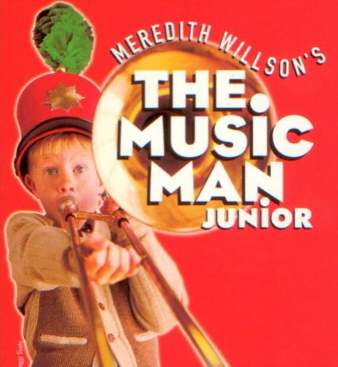

Teacher Contact Info:

Mrs. Hendrix
Shayla.Hendrix@legacytraditional.org
Mrs. Fraser
Rachael.Fraser@legacytraditional.org
Mrs. Vizcaino
denice.vizcaino@legacytraditional.orgMrs. Bennett
Shawna.Bennett@legacytraditional.org
Mrs. Moran
Jennifer.Moran@legacytraditional.org

1st Grade News
1st Grade is Outstanding!

March 25-29th, 2013


Please check out the 1st grade website. There are many resources on there to help your child practice at home. Grammar pages, handwriting practice pages, and resources to help with math!

http://legacytraditionalschool-maricopa-1stgrade.yolasite.com/

Login: 1stgradeLTS
Password: legacy1st

Don’t forget the competition for the class with the most Box Tops!!


Reading Fluency Ideas
- Conduct Reader’s Theatre as a family. Choose a story with dialogue or write a play, then act out different characters’ parts or have each person in the family read their line or selection in a story.
- Read Fluency Practice Passages nightly, for 1 minute. Each week, 1st grade will send home a reading practice passage. Time your child for 1 minute and have them read aloud. Count the number of words they read correctly. Encourage them to do faster each time.
- Read the weekly Imagine Stories nightly. It increases their fluency and comprehension exponentially.
- Speed Read. Reading for fluency is like reading for speed. Read you spelling words as fast as you can each night aloud.

Legacy Traditional Charter School

What are we learning?
Phonograms: Daily Oral and Written Phonogram Review (OPR,WPR)
Written Phonogram Review Quiz on Friday!!!

Spelling- List 23
Spelling Test Friday!!!!
Reading the Spelling words Assessment Friday!!!

Grammar/ Writing: Identify 4 types of sentences, plural nouns, regular and irregular verbs, possessive pronouns, and compound sentences, comparing adjectives
Grammar Test Friday!!
Informative Writing

Reading: Identify 1st or 3rd person point of view when reading narrative stories, read and discuss Homes (Imagine It). Be sure to bring back book daily.
Comprehension Test on Friday!!!
First 3 mental actions (monitoring comprehension, making connections, and making predictions)

Math: Fact Assessment 18-1 Monday, Fact Assessment 18-2, Written Assessment 18 Tuesday

Science: Matter

Spelling Review List 23

- bought 11. recover 21. bring
- paid 12. mountain 22. less
- pay 13. speak 23. event
- enter 14. past 24. off
- railroad 15. might 25. of
- unable 16. contract 26. true
- ticket 17. deal 27. truth
- account 18. almost 28. took
- driven 19. all 29. again
- real 20. brought 30.inform

1st Grade News
Newsletter, Page 2

