
Dates to Remember

August 24th - ½ Day: Progress Reports

September 3- Labor Day NO School

September 14- ½ Day: End of Grading Period 1

September 20-21- ½ Day Parent-Teacher Conferences
Notes from the Teacher

Wow! We made it through the first week of school! Thank you for sending in all of their school supplies and even some off the wish list, we really appreciate it. I received most of the student and parent forms, from Meet the Teacher, but if you haven’t returned those please do so. What a great week we had, there was a lot of learning going on. Thank you for working with your child on their homework and signing it every night. Please be sure your child is reading every night and you sign that they read. This week you will see a Decodable “Matt and Sam” in your child’s homework folder. I know it may seem really easy for many boys and girls, but please have your child read it nightly as well as other books of their choice. Remember this is just the beginning. Thank you to those who have sent in the math coins. We will be using our pennies this week! Keep an eye out for an email if you are interested in starting on your 12 hours of volunteering time. I will be emailing a schedule very soon! Thank you for a successful first week of school! If you have any questions or concerns please do not hesitate to email me at shawna.bennett@legacytraditional.org

Mrs. Hendrix

Happy Birthday to

Our August birthdays
The Key is Reading: Read, Read and Read!

Coming Soon!

See your child’s teacher for specials schedule details

Lunch Time
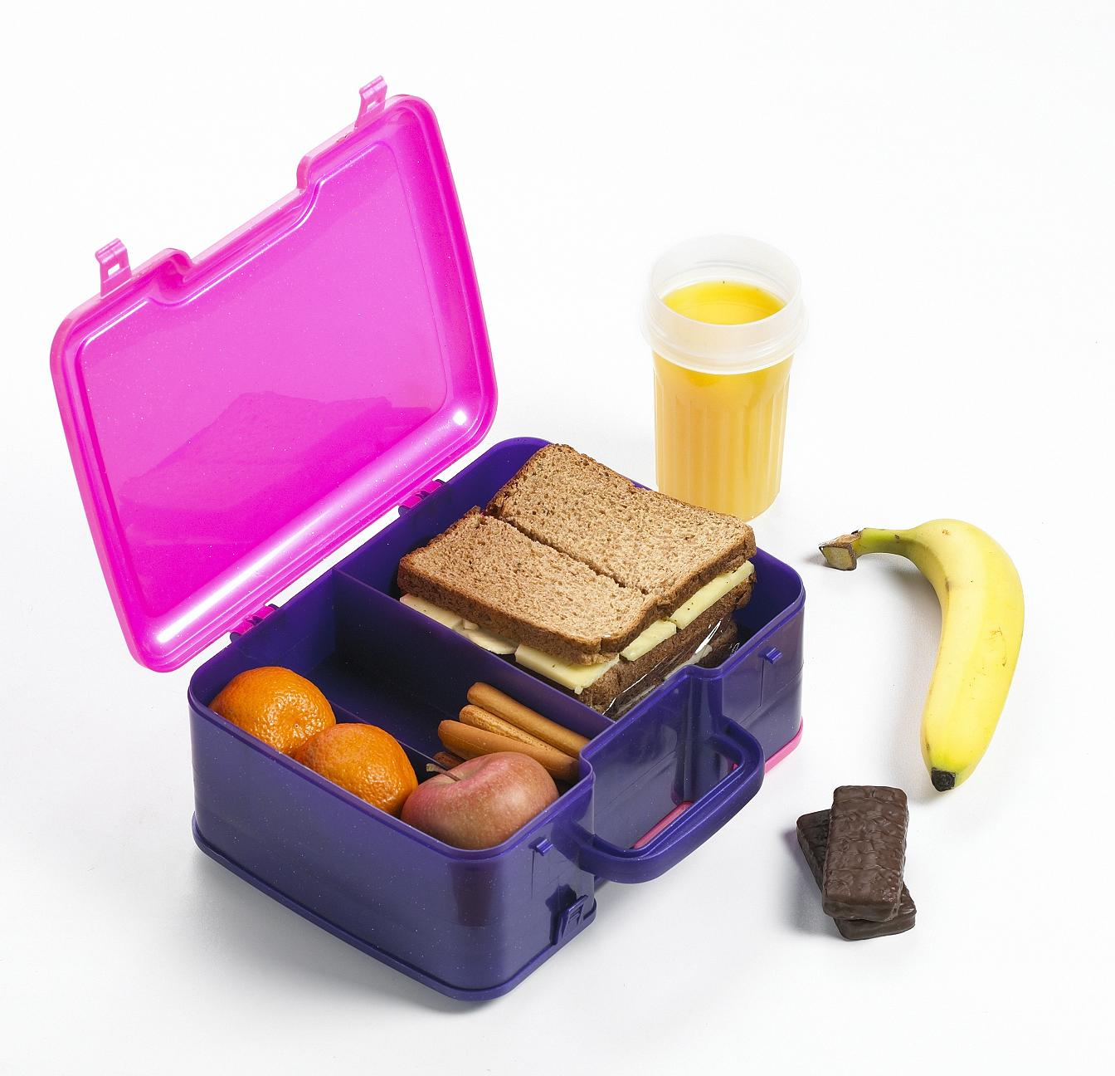
10:50-11:10

1st Grade News
1st Grade is Cool!
ISSUE 2
August 13, 2011

Student of the Week


What are we learning?
Phonograms: a, c, d, f, g, s, o, qu, b, e, h, I, j, k, l, m, n, p. r. t. u. v. w, w, y, z, sh, ee daily Oral and Written Phonogram Review (OPR,WPR) WRITTEN PHONOGRAM TEST FRIDAY!!!

Writing: Six Features of writing, top-line, mid-point, base-line, clock letters

Grammar: Oral Sentences

Reading: Narrative Elements: Characters, Plot, Setting, Author’s Purpose. Matt & Sam Comprehension Test Friday

Math: Daily Fact practice, pattern blocks attributes, ordinal numbers, Story Problems (some and some more), comparing and ordering objects, problem solving.

Social Studies: Community Rules and Leaders

Character Education

GP1: Trustworthiness
Be honest • Don’t deceive, cheat, or steal • Be reliable — do what you say you’ll do • Have the courage to do the right thing • Build a good reputation • Be loyal — stand by your family, friends, and country

Thank you for being so patient at dismissal and bringing your Golden Sign EVERYDAY. This has been so helpful!

POEMS!!!
Check Homework folders for Poem Recitation Info this week!!

Legacy Traditional Charter School

1st Grade News
Newsletter, Page 2
What Extra Stuff Can we be Doing at Home?
- Practice your child’s birthday. Students at this age should know the month, day and year they were born.
- Make PHONOGRAM FLASHCARDS! Phonogram cards will be sent home this week. Please cut these out and make them into Phonogram Flashcards. Using index cards will help in creating these.
- Work on their handwriting helping guide their hand and even erasing and re-doing it. Use the Spalding verbiage we sent home in the homework folders.
- Read every night!

