
Notes from the Teacher

Welcome back to school! Even though it is still scorching hot outside, summer is over and we have an exciting year planned! I am so excited to be working with your child.
I want you to be involved in your child’s education and would love to have you come in and volunteer in the classroom. However, we will use the first 2 weeks of school to allow the students to get familiar with their routine and classroom procedures. After that we can schedule you to come in and help. We love moms, dads and even grandparents. I will be using a website called volunteerspot.com. I should have received your email at Meet the Teacher, if I did not, please email me or send it in with your child. Keep an eye out for an email from volunteerspot.com so you can sign up for the days you want. Please return any forms that were sent home to be signed.
If you have any questions or concerns please do not hesitate to email me at shawna.bennett@legacytraditional.org

Mrs. Bennett

Legacy Lions!
The Key is Reading: Read, Read and Read!

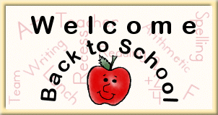
Coming Soon!

Happy Birthday to our August Friends!


Dates to Remember

August 24th - ½ Day: Progress Reports

September 3- Labor Day NO School

September 14- ½ Day: End of Grading Period 1

September 20-21- ½ Day Parent-Teacher Conferences

Specials:
Monday:
Music

Tuesday:
Computers/ Library (rotation)
Art Masterpiece

Wednesday:
PE

Thursday:
Music

Friday:
P.E.

Lunch Time
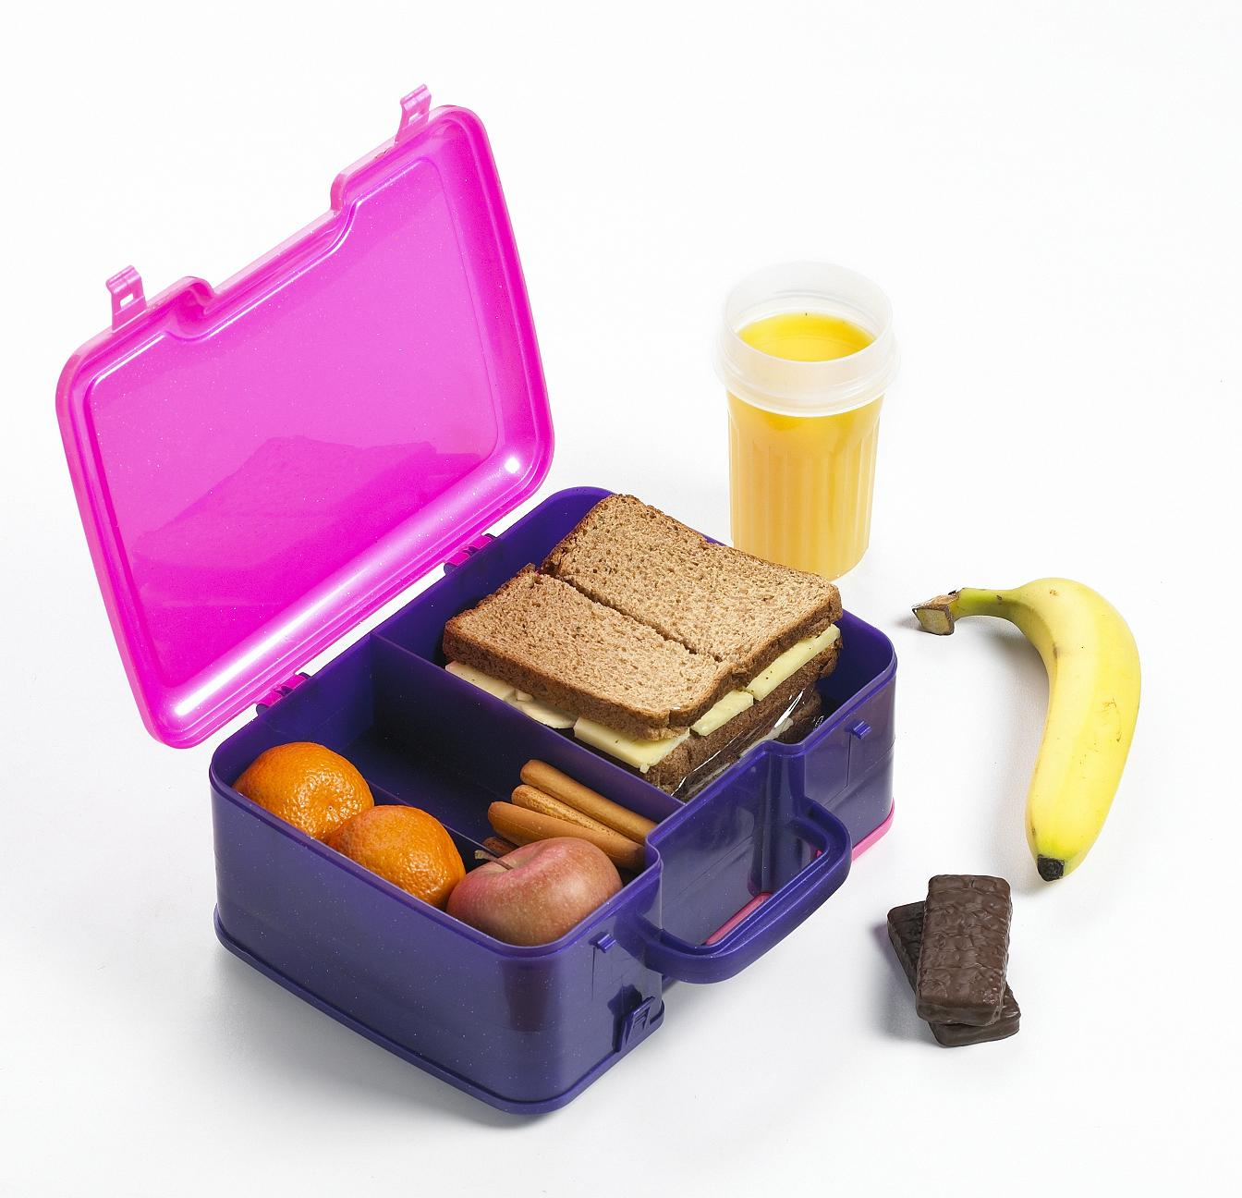
10:50-11:10

1st Grade News
1st Grade is AWESOME!
ISSUE 1
August 8, 2012

Student of the Week


Please send in the Math Coins requested this will help your child get hands-on experience during Math. These will be returned at the end of the year.
20 pennies, 10 dimes, 12 nickels, 8 quarters
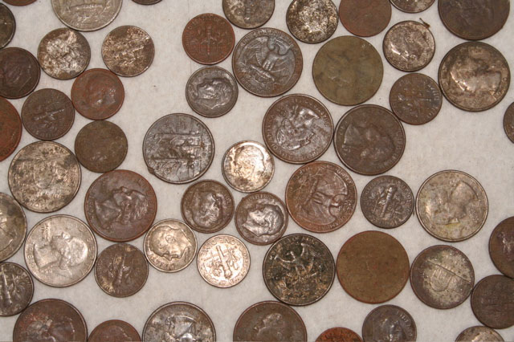
Phonograms

Remember to study your flashcards NIGHTLY!

They will be sent home nightly with the homework, cut them, fold and keep in a plastic bag. Phonogram cards can be purchased through the office or online.

Character Education

GP1: Trustworthiness
Be honest • Don’t deceive, cheat, or steal • Be reliable — do what you say you’ll do • Have the courage to do the right thing • Build a good reputation • Be loyal — stand by your family, friends, and country

DON’T FORGET!!!
Send your child with a water bottle to school labeled with their first and last name. They may also bring a snack for afternoon recess.


Legacy Traditional Charter School

What are we learning?
Phonograms: a,c,d,f,g,o,s,qu,b,e,h,i
Writing: Six Features of writing, top-line, mid-point, base-line, clock letters
Grammar:Oral Sentences
Reading:Narrative Elements: Characters, Plot, Setting, Author’s Purpose
Math: Reading and identifying numbers to 100, and identifying left and right, one more, one less.
Social Studies: School Rules

1st Grade News
Newsletter, Page 2
Spelling List

No Spelling Words

