Dear Parents,
Let the journey begin! Your child will be going on an adventure to the country of
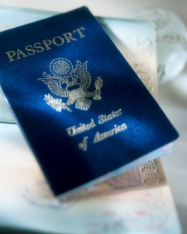
_______________________________________________. Please encourage your child to find out everything they can about their assigned country through books, Internet, and other resources. This should be a journey that is taken a little at a time and showcases their best quality work. The completion of the tri-fold presentation board (see attached criteria) and the student presentation at the Cultural Fair will take the place of book reports and poems for the 6th grading period. Please do not let your child wait until the last minute to start working on this project.
The tri-fold presentation boards are due on May 7th.
The Culture Fair will be taking place on May 8th and 9th from 1:30 until 2:30 pm
in your child’s classroom.
May 8th presenters will be Mrs. Hendrix, Mrs. Fraser and Mrs. Bennett’s classes.
May 9th presenters will be Mrs. Vizcaino and Mrs. Moran’s classes.

Each student will need to complete a tri-fold presentation board to present the information they learned about their country to the other first grade classes and parents. Remember to do your best quality work by using Spalding handwriting and neatness when completing this project. Students are also highly encouraged to add to their display by bringing in additional items that represent their country such as money, music, food, or anything else that would be special to their country. Please bring in these items on the day of the Cultural Fair. Let your child’s teacher know ahead of time that you will be bringing in items so that we may allow for additional space for these items. If you have any questions or concerns throughout this journey please contact your child’s teacher. Thank you for all of your wonderful support and enjoy the journey with your child. First grade parents are the best!

Sincerely,

The First Grade Team

