Attach the front to the back by stapling on the sides and bottom edges & put items inside.
This is the back of the suitcase.

Complete and color all items, cut them out, and put them in the suitcase. You create the suitcase by stapling the front and back along the side and bottom edges.
Author
Title of Book

(Write on the back of this piece.)
First Aid Kit
What happened at the end of the book?

Complete and color all items, cut them out, and put them in the suitcase. You create the suitcase by stapling the front and back along the side and bottom edges.
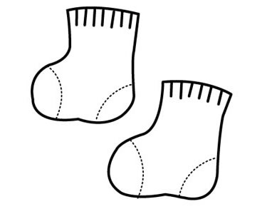
Complete and color all items, cut them out, and put them in the suitcase. You create the suitcase by stapling the front and back along the side and bottom edges.

_____________________________

_____________________________
What happened in the beginning of the book?
What happened in the middle of the book?
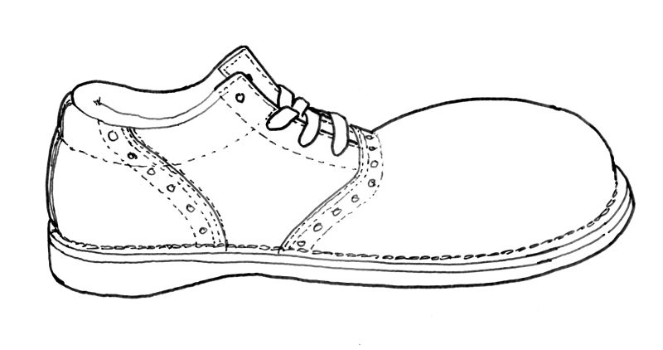
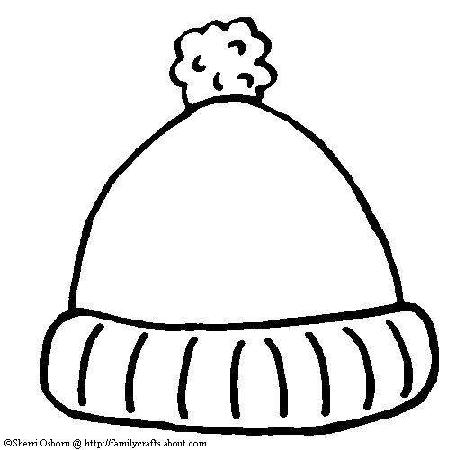
Complete and color all items, cut them out, and put them in the suitcase. You create the suitcase by stapling the front and back along the side and bottom edges.
Did you like the book?
_______________
What was your favorite part of the book?

Complete and color all items, cut them out, and put them in the suitcase. You create the suitcase by stapling the front and back along the side and bottom edges.
Setting
__________________

My Traveling
Book Report
By:
____________________________________
Favorite Character

_________________
Characters in the Book
_______________________________________________________________________________________________
A picture of my favorite character
Tell all about your character
______________________________________________________________________________________________________________

