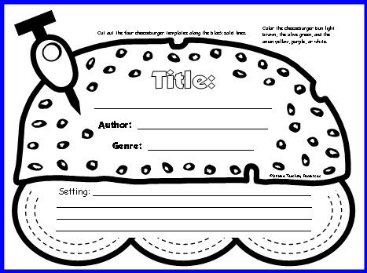
Cut out the four cheeseburger templates along the black solid line.
Color the cheeseburger bun light brown, the olive green, and the onion yellow, purple, or white.
Setting (when and where the story takes place):
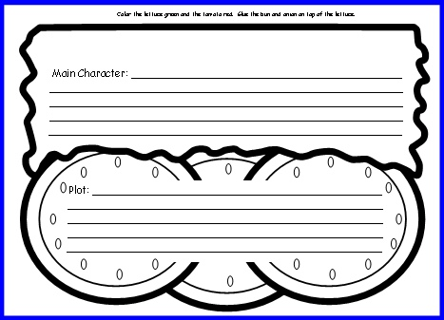
Color the lettuce green and the tomato red. Glue the bun and onion on top of the lettuce.
Plot (what happened) in one sentence:
Main Character:
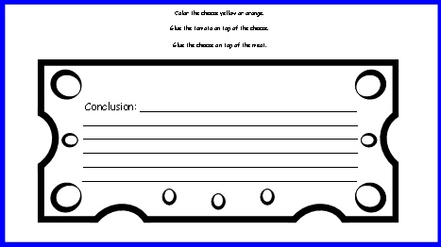
Color the cheese yellow or orange.
Glue the tomato on top of the cheese.
Glue the cheese on top of the meat.
End of story in one sentence:

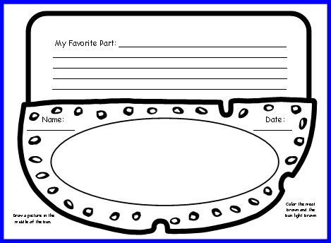
Color the meat brown and the bun light brown.
Draw a picture in the middle of the bun.
My Favorite Part in one sentence:

Cheeseburger Book Report
First Grade Book Report / Third Grading Period
My Favorite Part:
Instructions:
- Choose a book that it is appropriate for your child’s age and interest level. Read the book with your child.
- Help your child complete the attached sheets using the book as your reference. Please make sure that correct capitalization/ punctuation is used, and that they write complete sentences where sentence-writing is indicated.
- Ensure that your child colors each of the parts of the cheeseburger as instructed on the sheets. They will be cutting them out and assembling them in the classroom.
Practice Presenting at Home--
It is a good idea to have your child practice presenting his/her cheeseburger book report to you at home before s/he does it in the classroom. This helps develop confidence for when they do it in the classroom.

